Automated Payment processing
Safe - Convenient - Easy

We are excited to offer the safety, convenience and ease of Tuition Express™ –
an automatic payment processing system that allows on-time tuition and fee payments.

Trinity Lutheran School uses Tuition Express for K-8 Tuition, Extended Care and Camp Trinity.
Please initial and choose one method of payment.
K-8 Tuition (initial one):
______ I will make a one-time annual payment in full for my child(ren). I will receive a 5% discount off the tuition only.
The 5% discount does not apply if you receive any tuition assistance or scholarships.
The 5% discount does not apply to any Registration, New Student, or PTL Fees.
______ I will make monthly payments through Tuition Express beginning July 1, 2019.
Tuition Express processing fees are the responsibility of the parent/guardian.
______ I would like to arrange an alternative payment schedule with the Finance Department.
Additional K-8 Fees (initial all that apply):
______I will pay the New Student Fee through Tuition Express.
______ I will pay the Registration Fee through Tuition Express.
______ I will pay the PTL Fee through Tuition Express.
Extended Care (initial one):
______ Weekly – Drop-in charges will be billed the Monday following the week of care.
______ Monthly – Monthly charges will be billed the first Friday of each month.
Monthly rates include Mini-Camps.
Monthly rates do not include Camp Trinity –Thanksgiving Break, Spring Break, or Summer Camp
Extended Care Registration Fee: (initial, if applicable)
______ I will pay the Registration Fee through Tuition Express.
Camp Trinity- Thanksgiving Break / Spring Break / Summer Camp (initial if you plan to send your children to any camp):
______ Weekly charges will be billed on the Friday prior to the week of camp my child is registered to attend.
Camp Trinity Registration Fee: (initial, if applicable)
______ I will pay the Registration Fee through Tuition Express.
*See next page to choose your method of payment through Tuition Express.*

AUTHORIZATION FOR CREDIT CARD
Choose One Payment Method
(Do not complete this portion if you intend to use your Checking Account for Electronic Funds Transfer.)
I hereby authorize Trinity Lutheran School to initiate recurring credit card charges for the items initialed on the previous page to my referenced credit card account. I understand that a transaction fee of $5.00 will be added to my bill each week for the ability to use my debit/credit card as my source of payment. To properly effect the cancellation of this agreement, I am required to give a 10 day written notice. Tuition Express accepts Discover, MasterCard, and Visa. **NOTE: There will be a $25.00 fee for all declined transactions.

_______________________________________________________________________________________________________________________________________
Cardholder Name Phone #

_______________________________________________________________________________________________________________________________________
Cardholder Address City State Zip

_______________________________________________________________________________________________________________________________________
FULL Credit Card Number Expiration Date Three Digit Security Code

_______________________________________________________________________________________________________________________________________
Signature Today's Date

AUTHORIZATION FOR BANK ACCOUNT ELECTRONIC FUNDS TRANSFER
(Do not complete this portion if you intend to use your debit/credit card for payments.)
I hereby authorize Trinity Lutheran School to initiate debit entries from my Checking or Savings Account indicated below in accordance with my selected payment schedule on the previous page. I understand that there is no fee for using my Bank Account as my source of payment. To properly effect the cancellation of this agreement, I am required to give a 10 day written notice.
**NOTE: There will be a $25 fee for all NSF transactions.
Credit Union Members: Please contact your Credit Union to verify account and routing numbers for automatic payments.

_______________________________________________________________________________________________________________________________________
Your Name Phone #

_______________________________________________________________________________________________________________________________________
Address City State Zip

_______________________________________________________________________________________________________________________________________
Bank or Credit Union Name

_______________________________________________________________________________________________________________________________________
Bank or Credit Union Address City State Zip
Checking Savings
_______________________________________________________________________________________________________________________________________
Routing Transit Number (see sample below) Account Number (see sample below)

_______________________________________________________________________________________________________________________________________
Signature Date
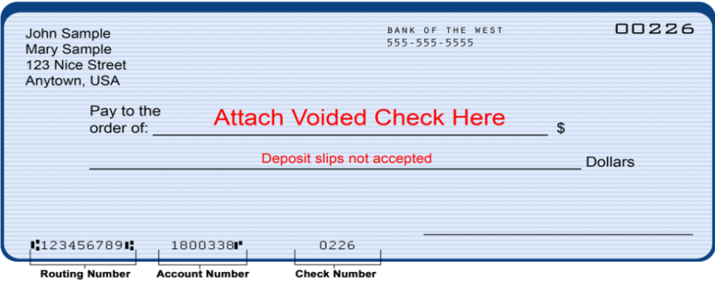
**You must supply a voided check or a pre-printed
voided deposit check with this section of the form.
The check or deposit slip must be printed with your
name, address, routing and account numbers.

For Official Use Only
_______________
Date Received
_______________________
Employee Signature

